**Business Intelligence Tech Screening Exercise**

The exercise below is a nice sample of what types of work our team is responsible for. Please work through the questions below and send your answers to the recruiter before your tech screening, the answers will be discussed during your next interview.

**Overview:**​

Data on LinkedIn's B2B sales is stored in two tables (see next page for table pictures):

​

**Figure 1) Opportunity** {OpportunityID, AccountID, OwnerID, CreateDate,  CloseDate, Amount, Status}​

(show top 5 sample rows)​

​

**Figure 2) Opportunity_Line_Item** {OpportunityID, LineItemID, Units, Amount}​

(show top 5 sample rows)​

​

**Question 1 – Data Modeling:**Using Figure 1 & Figure 2

1. What do you think these tables and columns are capturing? Describe in plain English​
2. What relevant information is missing?
3. If you were to design the data to have more product details, what are the tradeoffs between including them as columns in the line item table vs. in a separate dimension table? What would you choose and why?

**Question 2 – SQL Query:** Using Figure 1 & Figure 2

1. Write a query that tracks $ sales by product by month​

**Question 3 – Business Judgement:**Please use the Product Sales Over Time graph below ​

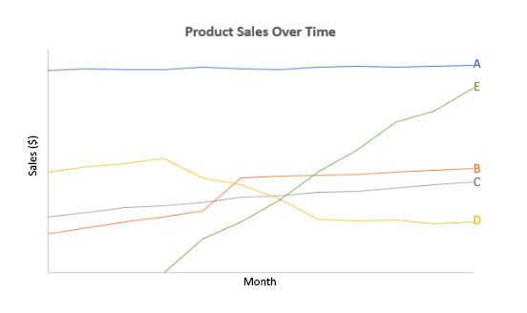

1. How would you describe Product A? If it were an actual LinkedIn product which would it be? ​
2. What’s going on with Product D? ​
3. What might explain the jump in sales of product B? What data in these tables might you want to investigate further?​

**Question 4 – Business Judgement:** Use the Product Sales Over Time graph

1. Based on this data, what strategic recommendations might you give?​

**Figure 1)** **Opportunity** {OpportunityID, AccountID, OwnerID, CreateDate,  CloseDate, Amount, Status}​

|  |  |  |  |  |  |  |
| --- | --- | --- | --- | --- | --- | --- |
| **OpportunityID​** | **AccountID​** | **OwnerID​** | **CreateDate​** | **CloseDate​** | **Amount​** | **Status​** |
| 0063200001o7xB3AAI​ | 0016000000m5Io3AAE​ | 00532000005L21IAAS​ | 11/25/16​ | 2/10/17​ | $8,485.29​ | Closed Won​ |
| 0063200001o7nxtAAA​ | 0016000000lbg4FAAQ​ | 00532000005L21IAAS​ | 11/22/17​ | NULL​ | $25,673.44​ | Open​ |
| 0066000000ROPX6AAP​ | 0016000000m3a51AAA​ | 00560000001BLCsAAO​ | 06/04/17​ | 06/24/17​ | $12,448.70​ | Closed Won​ |
| 0066000000IndvoAAB​ | 0016000000dfUI9AAM​ | 00560000001BLCsAAO​ | 09/16/11​ | 03/28/12​ | $33,835.21​ | Closed Won​ |
| 0066000000Ah7rpAAB​ | 0016000000JuVPQAA3 | 005600000010BHIAA2​ | 07/01/17​ | 07/02/17​ | NULL​ | Refused​ |

**Figure 2) Opportunity_Line_Item** {OpportunityID, LineItemID, Units, Amount}​

|  |  |  |  |
| --- | --- | --- | --- |
| **OpportunityID​** | **LineItemID​** | **Units​** | **TotalAmount​** |
| 0066000000ROPX6AAP​ | 00k6000000JG6kCAAT​ | 1​ | $10,892.70​ |
| 0066000000ROPX6AAP​ | 00k6000000JG6kDAAT​ | 1​ | $1,556.00​ |
| 0066000000IndvoAAB​ | 00k60000009MZjmAAG​ | 1​ | $7,123.20​ |
| 0066000000IndvoAAB​ | 00k60000009MZjcAAG​ | 1​ | $10,176.00​ |
| 0066000000IndvoAAB​ | 00k60000009MZjhAAG​ | 1​ | $9,921.60​ |
| 0066000000IndvoAAB​ | 00k60000009MZjXAAW​ | 5​ | $1,322.88​ |